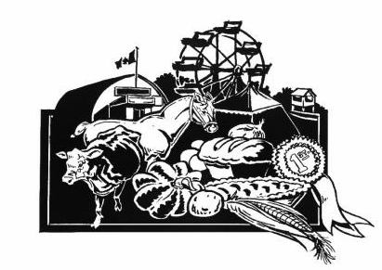

**Application – Coldwater Fall Fair Ambassador Contestant (Ages 16-24)**

***The Coldwater Fall Fair Ambassador competition will be held on Sunday, September 14, 2025 at 11 am, upstairs at the Coldwater Arena. Friends and family may come to support you and cheer you on beginning at 12 noon.***

The Coldwater Fall Fair Ambassador Program is a leadership opportunity for rural youth in and around the Coldwater area. Being an Ambassador is a rewarding experience that helps to develop confidence and life skills and encourages the participants to be involved in their community.

The Ambassador doesn’t have to be an expert in agriculture, live on a farm, or have grown up in Coldwater. It’s all about having fun, exploring your own potential and learning new things about yourself and your community while you give back in a most amazing way.

***Each contestant will have a private interview with the judges. All contestants will introduce themselves to the judges and guests by presenting their bio, which includes their name, school/grade or occupation, hobbies, interests, and any fun facts about themselves. After that they will deliver a 3 to 5 minute prepared talk on any topic they choose. A final fun surprise task will be required of each contestant. There will be prizes for all participants, and a financial bursary for the Ambassador which will be payable in four instalments over the course of the year.***

**APPLICATION SUBMISSION DEADLINE:**

***Please submit your application no later than Wednesday, September 10, 2025*** at the Severn Township Public Library (Coldwater) or directly to one of the Coordinators listed below.

If you have any questions or would like more information, please contact one of the Coordinators.

Thank you for your interest in this competition!

Coldwater Fall Fair Ambassador Program Coordinators

Monika Marsh Cheryle Bidmead-Malone

905-767-1623 705-835-3287

[monika.c.marsh@gmail.com](mailto:monika.c.marsh@gmail.com) [cheryle.bidlone@hotmail.com](mailto:cheryle.bidlone@hotmail.com)

**Coldwater Fall Fair**

**Ambassador of the Fair Competition**

**Application Form**

**NAME: ________________________________________________________________________________________**

**ADDRESS: _____________________________________________________________________________________**

**TELEPHONE: _________________________________**

**DATE OF BIRTH: ______________________________**

**E-MAIL:_____________________________________**

**EDUCATION:**

**Secondary: __________________________________________________________________________________**

**Post Secondary: ______________________________________________________________________________**

**Other (including future plans for post secondary education): _________________________________________**

**____________________________________________________________________________________________**

**EMERGENCY CONTACT:**

**Contact Name: _________________________________________________________________________________**

**Telephone: ____________________________**

**PLEASE TELL US ABOUT YOURSELF**—**INTERESTS, HOBBIES, FUTURE ASPIRATIONS* ______________________________________________________________________________________________**

**______________________________________________________________________________________________**

**______________________________________________________________________________________________**

**WHY DO YOU WANT TO BE THE AMBASSADOR FOR THE COLDWATER FALL FAIR?\***

**______________________________________________________________________________________________**

**______________________________________________________________________________________________**

**______________________________________________________________________________________________**

**PLEASE DESCRIBE ANY VOLUNTEER AND COMMUNITY INVOLVEMENT\***

**______________________________________________________________________________________________**

**______________________________________________________________________________________________**

**______________________________________________________________________________________________**

***\*Please feel free to attach additional pages if desired***

**Application Deadline:  Wednesday, September 10, 2025**

I hereby give my permission to the CFF Ambassador Program Coordinators to release the information on this form to the judges and the media.

***Signature of Applicant  Date***

***___________________________ ___________________________***

**Thank you for your interest in the 2025 Coldwater Fall Fair Ambassador Program**

**CFF Ambassador Program Coordinators**

