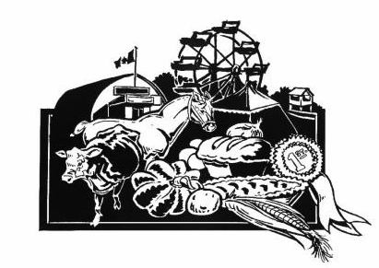

**Application – Coldwater Fall Fair Golden Ambassador Contestant (Age 60+)**

***The Coldwater Fall Fair Golden Ambassador competition will be held on Sunday, September 14, 2025 at 11 am, upstairs at the Coldwater Arena. Friends and family may come to support you and cheer you on beginning at 12 noon.***

The Coldwater Fall Fair Golden Ambassador Program is an opportunity to meet new people, try new things, and share fun and interesting memories of past fairs.

The Coldwater Fall Fair is the first Fair in Ontario to have a Golden Ambassador! Our residents over age 60 have a unique perspective to offer to the Fair attendees, and the Golden Ambassador role provides them with a wonderful opportunity to share it. The ambassadors don’t have to be experts in agriculture, live on a farm, or have grown up in Coldwater. It’s all about having fun, exploring your own potential and learning new things about yourself and your community while you give back in a most amazing way.

***Each contestant will have a private interview with the judges. All contestants will then introduce themselves to the judges and guests by presenting their bio, which includes their name, hobbies, interests, and any fun facts about themselves. After that they will talk for 3 to 5 minutes about their favourite memories of the Coldwater Fall Fair. Best of all -- ALL CONTESTANTS WILL BE WINNERS! We can never have enough Golden Ambassadors at the Fair! There will be prizes for all participants.***

**APPLICATION SUBMISSION DEADLINE**

***Please submit your application no later than Wednesday, September 10, 2025*** at the Severn Township Public Library (Coldwater) or directly to one of the Coordinators listed below.

If you have any questions or would like more information, please contact one of the Coordinators.

Thank you for your interest in this competition!

Coldwater Fall Fair Ambassador Program Coordinators

Monika Marsh Cheryle Bidmead-Malone

905-767-1623 705-835-3287

[monika.c.marsh@gmail.com](mailto:monika.c.marsh@gmail.com) [cheryle.bidlone@hotmail.com](mailto:cheryle.bidlone@hotmail.com)

**Coldwater Fall Fair**

**Golden Ambassador of the Fair Competition**

**Application Form**

**NAME: ________________________________________________________________________________________**

**ADDRESS: _____________________________________________________________________________________**

**TELEPHONE: _________________________________**

**PLEASE CONFIRM THAT YOU ARE OVER 60 YEARS OF AGE: ______________________________**

**E-MAIL:_____________________________________**

**EMERGENCY CONTACT:**

**Contact Name: _________________________________________________________________________________**

**Telephone: ____________________________**

**PLEASE TELL US ABOUT YOURSELF**—**INTERESTS, HOBBIES, LIFE EXPERIENCES ______________________________________________________________________________________________**

**______________________________________________________________________________________________**

**______________________________________________________________________________________________**

**WHY DO YOU WANT TO BE THE GOLDEN AMBASSADOR FOR THE COLDWATER FALL FAIR?**

**______________________________________________________________________________________________**

**______________________________________________________________________________________________**

**______________________________________________________________________________________________**

**PLEASE DESCRIBE ANY VOLUNTEER AND COMMUNITY INVOLVEMENT**

**______________________________________________________________________________________________**

**______________________________________________________________________________________________**

**______________________________________________________________________________________________**

**Application Deadline:  Wednesday, September 10, 2025**

I hereby give my permission to the CFF Ambassador Program Coordinators to release the information on this form to the judges and the media.

***Signature of Applicant  Date***

***___________________________ ___________________________***

**Thank you for your interest in the 2025 Coldwater Fall Fair Ambassador Program**

**CFF Ambassador Program Coordinators**