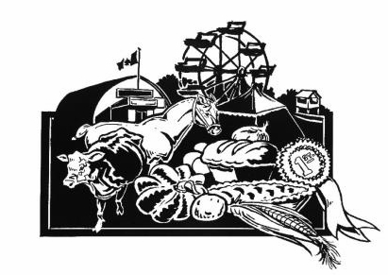
Application – Coldwater Fall Fair Ambassador Contestant (Ages 16-26)

The Coldwater Fall Fair Ambassador competition will be held on Sunday, August 16, 2026 at 11 am, upstairs at the Coldwater Arena. Friends and family may come to support you and cheer you on beginning at 12 noon.
The Coldwater Fall Fair Ambassador Program is a fun and rewarding leadership opportunity for rural youth in and around the Coldwater area. Being an Ambassador gets you involved in the Fair and your Community in a very visible way and helps to develop confidence and life skills along the way.
The Ambassador doesn’t have to be an expert in agriculture, live on a farm, or have grown up in Coldwater. It’s all about having fun, exploring your own potential and learning new things. The Ambassador role puts you front and centre at events throughout the weekend of the Fair. You will get a whole new perspective on what’s involved in making the Fair the amazing event that it always is!

Each contestant will have a private interview with the judges. All contestants will introduce themselves to the judges and guests by presenting their bio, which includes their name, school/grade or occupation, hobbies, interests, and any fun facts about themselves. After that they will deliver a 3 to 5 minute prepared talk on any topic they choose that relates in some way to agriculture. A final fun, surprise task will be required of each contestant. There will be prizes for all participants, and a financial bursary for the Ambassador which will be payable in four instalments over the course of the year.

APPLICATION SUBMISSION DEADLINE:
Please submit your application no later than Monday, August 10, 2026 at the Severn Township Public Library (Coldwater) or directly to one of the Coordinators listed below.

If you have any questions or would like more information, please contact one of the Coordinators.
Thank you for your interest in this competition and the Coldwater Fall Fair!

Coldwater Fall Fair Ambassador Program Coordinators
Monika Marsh Cheryle Bidmead-Malone
905-767-1623 705-835-3287
monika.c.marsh@gmail.com cheryle.bidlone@hotmail.com

Coldwater Fall Fair
Ambassador of the Fair Competition
Application Form
NAME: ________________________________________________________________________________________
ADDRESS: _____________________________________________________________________________________
TELEPHONE: _________________________________
DATE OF BIRTH: ______________________________
E-MAIL:_____________________________________
EDUCATION:
Secondary: __________________________________________________________________________________
Post Secondary: ______________________________________________________________________________
Other (including future plans for post secondary education): _________________________________________
____________________________________________________________________________________________
EMERGENCY CONTACT:
Contact Name: _________________________________________________________________________________
Telephone: ____________________________
PLEASE TELL US ABOUT YOURSELF—INTERESTS, HOBBIES, FUTURE ASPIRATIONS* ______________________________________________________________________________________________
______________________________________________________________________________________________
______________________________________________________________________________________________
WHY DO YOU WANT TO BE THE AMBASSADOR FOR THE COLDWATER FALL FAIR?*
______________________________________________________________________________________________
______________________________________________________________________________________________
______________________________________________________________________________________________
PLEASE DESCRIBE ANY VOLUNTEER AND COMMUNITY INVOLVEMENT*

______________________________________________________________________________________________
______________________________________________________________________________________________
______________________________________________________________________________________________

*Please feel free to attach additional pages if desired

Application Deadline: Monday, August 10, 2026

I hereby give my permission to the CFF Ambassador Program Coordinators to release the information on this form to the judges and the media.
Signature of Applicant Signature of Parent/Guardian Date
___________________________ ___________________________ __________________
(Required if Applicant is under 18)

Thank you for your interest in the 2026 Coldwater Fall Fair Ambassador Program
CFF Ambassador Program Coordinators

