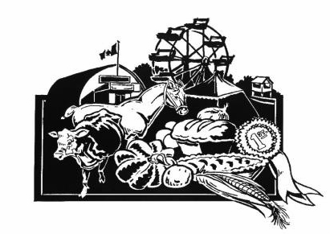
Application – Coldwater Fall Fair Golden Ambassador Contestant (Age 60+)

The Coldwater Fall Fair Golden Ambassador competition will be held on Sunday, Sunday, August 16, 2026 at 11 am, upstairs at the Coldwater Arena. Friends and family may come to support you and cheer you on beginning at 12 noon.
The Coldwater Fall Fair Golden Ambassador Program is an opportunity to meet new people, try new things, and share fun and interesting memories of past fairs. The Golden Ambassador doesn’t have to be an expert in agriculture, live on a farm, or have grown up in Coldwater. It’s all about having fun, exploring your own potential and learning new things. The Golden Ambassador role puts you front and centre at events throughout the weekend of the Fair. You will get a whole new perspective on what’s involved in making the Fair the amazing event that it always is!

In 2024, the Coldwater Fall Fair was the first Fair in Ontario to introduce a Golden Ambassador! Our “golden” residents have a unique perspective to offer to the Fair attendees, and the Golden Ambassador role provides them with a wonderful opportunity to share it.

Each contestant will have a private interview with the judges. All contestants will then introduce themselves to the judges and guests by presenting their bio, which includes their name, hobbies, interests, and any fun facts about themselves. After that they will talk for 3 to 5 minutes about their favourite memories of the Coldwater Fall Fair. Best of all -- ALL CONTESTANTS WILL BE WINNERS! We can never have enough Golden Ambassadors at the Fair! There will be prizes for all participants.

APPLICATION SUBMISSION DEADLINE
Please submit your application no later than Monday, August 10, 2026 at the Severn Township Public Library (Coldwater) or directly to one of the Coordinators listed below.

If you have any questions or would like more information, please contact one of the Coordinators.
Thank you for your interest in this competition and the Coldwater Fall Fair!

Coldwater Fall Fair Ambassador Program Coordinators
Monika Marsh Cheryle Bidmead-Malone
905-767-1623 705-835-3287
monika.c.marsh@gmail.com cheryle.bidlone@hotmail.com

Coldwater Fall Fair
Golden Ambassador of the Fair Competition
Application Form
NAME: ________________________________________________________________________________________
ADDRESS: _____________________________________________________________________________________
TELEPHONE: _________________________________
PLEASE CONFIRM THAT YOU ARE OVER 60 YEARS OF AGE: ______________________________
E-MAIL:_____________________________________
EMERGENCY CONTACT:
Contact Name: _________________________________________________________________________________
Telephone: ____________________________
PLEASE TELL US ABOUT YOURSELF—INTERESTS, HOBBIES, LIFE EXPERIENCES ______________________________________________________________________________________________
______________________________________________________________________________________________
______________________________________________________________________________________________
WHY WOULD YOU LIKE TO BE A GOLDEN AMBASSADOR FOR THE COLDWATER FALL FAIR?
______________________________________________________________________________________________
______________________________________________________________________________________________
______________________________________________________________________________________________

PLEASE DESCRIBE ANY VOLUNTEER AND COMMUNITY INVOLVEMENT
______________________________________________________________________________________________
______________________________________________________________________________________________
______________________________________________________________________________________________

Application Deadline: Monday, August 10, 2026

I hereby give my permission to the CFF Ambassador Program Coordinators to release the information on this form to the judges and the media.
Signature of Applicant Date
___________________________ ___________________________

Thank you for your interest in the 2026 Coldwater Fall Fair Ambassador Program
CFF Ambassador Program Coordinators

